PHASE 02: REQUIREMENT ANALYSIS
TECHNOLOGY STACK SPECIFICATION

Date | 18 July 2026
Team ID | SB-IBM-2026-07-0012
Project Name | Customer Care Registry System
Maximum Marks | 4 Marks

Project Team Members & Roles:
• Priyanka Degala - Team Lead (PD) - Frontend Developer
• Chandrakala Marri - Member (CM) - Backend Design & QA Testing
• Eswarasai Marre - Member (EM) - Backend Developer
• Triloka Pavani Mandhapati - Member (TPM) - Database Developer
• Santhosh Nikhil Moka - Member (SNM) - Fullstack Feature Developer
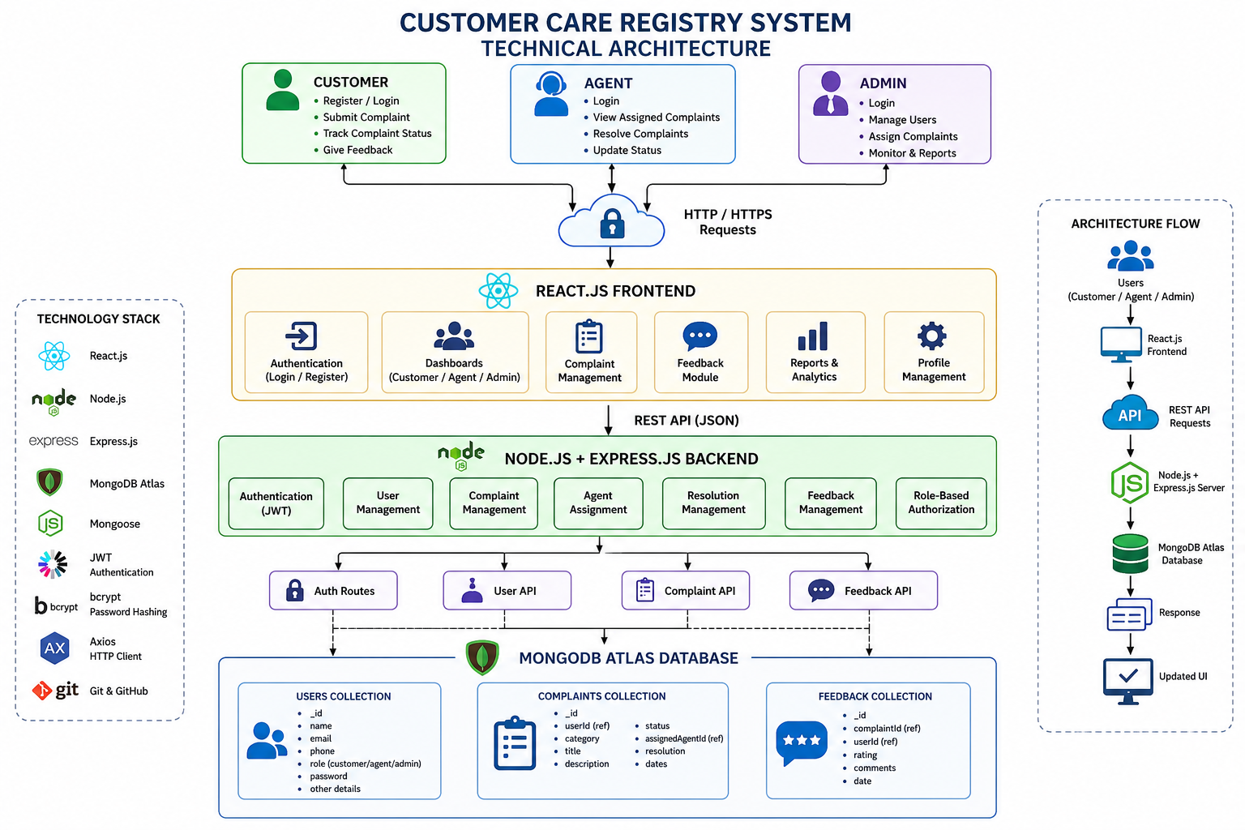
1. Core Technology Stack
S.No | Component | Description | Technology
1 | User Interface | Single Page Application frontend. | React.js, HTML5, CSS3, Vite
2 | Application Logic | RESTful API Server routing and controllers. | Node.js, Express.js
3 | Database | Document persistent data storage. | MongoDB Atlas (NoSQL)
4 | Authentication | Stateless session tokens. | JSON Web Tokens (JWT)
5 | Security | Cryptographic password hashing. | bcrypt.js
6 | File Storage | Handling file attachments. | Local Server Storage (via Multer)

2. System Characteristics
S.No | Characteristics | Description | Technology
1 | Open-Source Frameworks | Use verified, modern open-source modules. | Express.js, Mongoose, React, Axios, bcrypt.js, cors
2 | Security Implementations | Encrypt storage and prevent cross-origin leak vulnerabilities. | Bcrypt password hashing, JWT stateless authorization, CORS middleware configurations
3 | Scalable Architecture | Utilize a modular, stateless 3-tier layout. | 3-Tier architecture (React SPA client, Node API, Mongo Atlas)
4 | Availability | Use automatic restart monitoring software. | PM2 cluster management, Atlas replica-set deployment
5 | Performance | Support fast response latencies under concurrent access. | MongoDB indexes, stateless session operations, async Event Loop processes

